Project Design Phase
Problem – Solution Fit Template

Date | 18 February 2026
Team ID | LTVIP2026TMIDS79720
Project Name | Advancing Nutrition Science through Geminiai
Maximum Marks | 2 Marks

Problem – Solution Fit Template:
Advancing Nutrition Science through GeminiAI is a cutting-edge web application that leverages Google Gemini 1.5 Flash to democratize access to expert nutritional guidance. Built with Streamlit, the platform features three primary modules: Dynamic Nutritional Insights for real-time calorie and macro analysis, Tailored Meal Planning for creating personalized 7-day diets based on health goals and allergies, and Virtual Nutrition Coaching for interactive, evidence-based advice. By integrating secure API management and sophisticated prompt engineering, the tool empowers users to make informed dietary choices through a user-friendly, secure, and highly responsive interface.

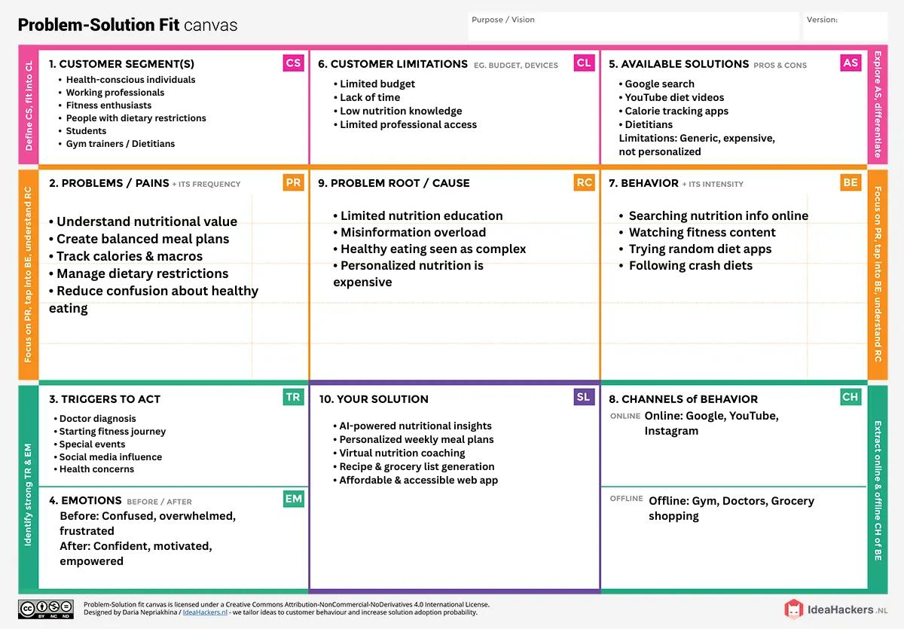

References:
- https://www.ideahackers.network/problem-solution-fit-canvas/
- https://medium.com/@epicantus/problem-solution-fit-canvas-aa3dd59cb4fe

